

Year 10

Mini Test 2

Probability

Total Marks: 25 marks
Name: ______________________ Class:_______ Total Time: 25 minutes

Show working and answers on this sheet. Show working in sufficient detail to support your answers. Incorrect answers without supporting reasoning may be allocated zero marks.

- Two normal dice numbered from 1 to 6, are thrown together
[6 marks]
  - Fill in the following two-way table to show all the possible totals.

First die
Second die

  - Find the probability the total will be 5.

  - If the two dice were rolled 180 times, how many times would you expect the total to be 5?

d. Find the probability the total will be 5, given that the first die lands on 3.

e. Find the probability that at least one die lands on 3, given the total is 5.

- Two cards are chosen from the following. The first is replaced before the second is chosen.
[4 marks]

H |  | A |  | T

  - List the sample space to show the outcomes.

  - Find the probability that I get AT

  - Find the probability that the outcome contains a H

- A bag contains three red, two yellow and four green marbles. Two marbles are taken from the packet, one after the other without replacing the first before the second is drawn.
[9 marks]
  - Complete the simplified tree diagram below showing the outcomes and the probabilities.

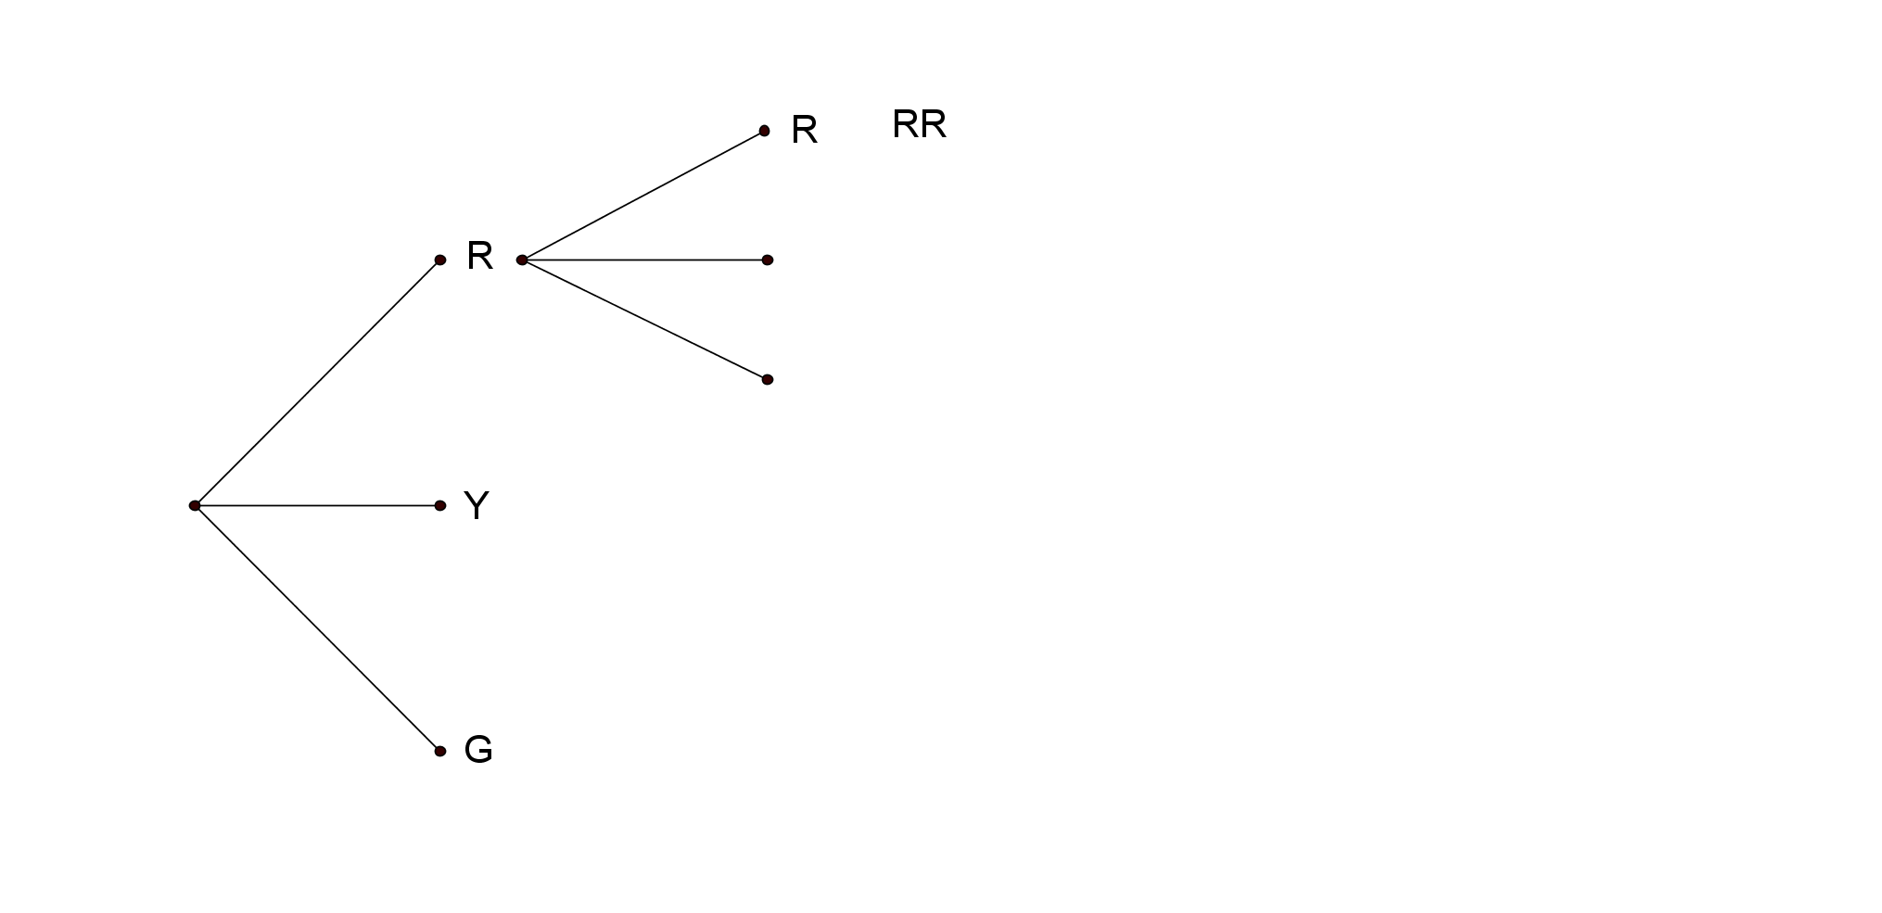
$$\frac{3}{9}$$
$$\frac{2}{8}$$
$$P(RR)=\frac{1}{12}$$

  - Find the probability that the first marble is green.

  - Find the probability that you get yellow then green.

  - Find the probability that you get red and green in any order.

  - If you replaced the first marble before choosing the second marble.

    - What effect would this have on the tree diagram?

    - Calculate the probability of getting a yellow then a green marble?

- The Venn diagram below shows the sports played by a group of year 10 students.
[6 marks]
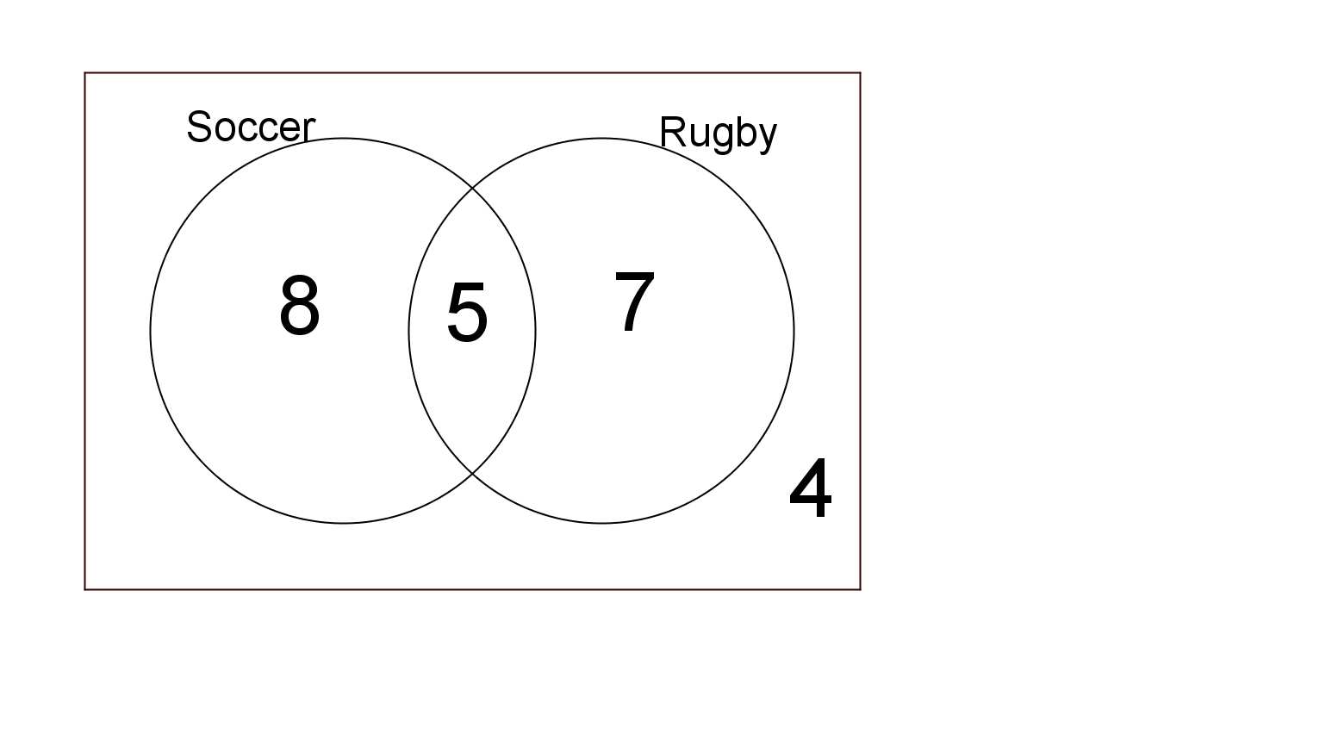
  - How many students in the group?
  - If one member of the group is chosen at random, what is the probability that they play soccer?
  - If one member of the group is chosen at random, what is the probability that they play soccer or rugby?
  - If one member of the group is chosen at random what is the probability that they play soccer and rugby?
  - If one member of the group is chosen at random, what is the probability that they play soccer, given that they play rugby?
  - If one member of the group is chosen at random, what is the probability that they play soccer given that they don’t play rugby?

